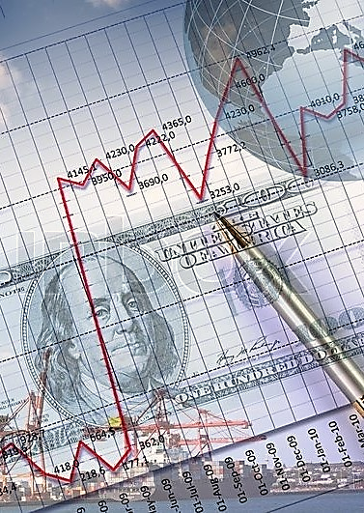

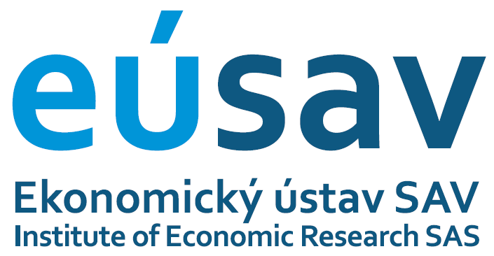



**invitation**

**INSTITUTE OF ECONOMIC RESEARCH SAS,**

**with the support of the association**

**INFORMAL ECONOMIC FORUM ECONOMIC CLUB, founded in 1993,**

**and KÁVOMATY LTD, Kežmarok**

**are inviting you to the international scientific seminar**

**FROM A UNIPOLAR TO A MULTIPOLAR**

**INTERNATIONAL SYSTEM**

**26th of September, 2016**

**Pálffy Palace**

**Zámocká 47, 811 01 Bratislava**

***Seminar Program:***

**9.15 – 9.20 Opening address, welcome speech**

***Juraj Sipko, Director of Institute of Economic Research SAS***

**9.20 – 9.50 Transition towards a multipolar international monetary system**

***Juraj Sipko, Institute of Economic Research SAS***

**9.50 – 10.10 New trends in a multipolar monetary and financial system**

***Leopold Tanner,*** ***CMI-CESMA, Madrid***

**10.10 – 10.30 Development of the USD & its impact on the price development of particular commodities**

***Obadi Saleh Mothana, Institute of Economic Research SAS***

**10.30 – 11.00 Coffee break**

**11.00 – 11.20 The position of USA, the EU and BRICS states in a multipolar world**

***Jiří Malý, Newton College, Prague***

**11.20 – 11.40 The European Union in a multipolar world**

***Staněk Peter, Institute of Economic Research SAS***

**11.40 – 12.00 Geopolitical cycles and the transformation of the global system in the 21st century**

***Oskar Krejčí, Institute of Global Studies UJAK, Prague***

**12.00 – 13.00 Discussion & conclusions**

**The moderator of the seminar will be:**

***Juraj Sipko, Director of Institute of Economic Research SAS***

***R.S.V.P.:*** *Please address to* ***lenka.bartosova@savba.sk*** *by the 5th of September, 2016.*